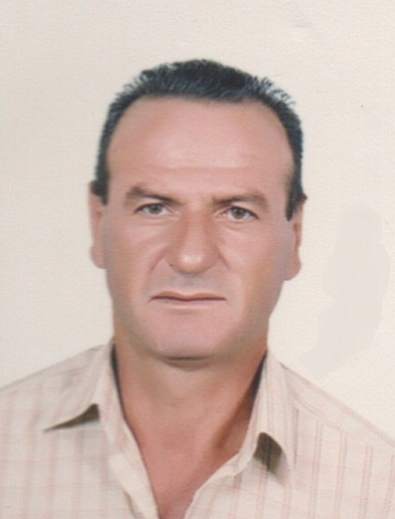**Résumé**

**Edmon Mtanious Salloum**

Faculty of petroleum Engineering

Syrian Private University

[Edmon.Salloum@spu.edu.sy](mailto:Edmon.Salloum@spu.edu.sy)

**BIODATA:**

Edmon Salloum is PhD holder from Gubken Insitute for Oil & Gas in Russian Federation. He is an associate professor at The Syrian Private University.

**EDUCATION:**

1994 Ph.D. in Petroleum Engineering, Gubken Insitute for Oil & Gas, Russian Federation.

1984 Petroleum Engineering, Al-Baath University, Homs, Syria.

**HONORS AND AWARDS:**

None

**EMPLOYMENT EXPERIENCE:**

2017 to date Dean of petroleum engineering faculty, Syrian Private University.

2011-2017 Head of reservoir engineering department, petroleum engineering faculty, Syrian Private University

2009-2010 Vice dean for scientific and administrative affairs, faculty of musical education, Al-Baath University.

2003-2009 Education staff, faculty of chemical and petroleum engineering, Al-Baath University.

1996-2003 Director of research and graduate studies, Al-Baath University.

1994-1996 Dr. Eng. in SPC, constructing and operating natural gas gathering & processing stations.

1994-1996 Lecturer of practical part of some subjects, faculty of chemical and petroleum engineering, Al-Baath University.

**RELEVANT PROFESSIONAL EXPERIENCE:**

None.

**COMMITTEE MEMBERSHIP**

None.

**PUBLICATIONS, TRANSLATIONS & CONTRIBUTIONS:**

**1. Books:**

2008 Engineering of natural gas extraction, faculty of chemical and petroleum engineering, Al-Baath University.

**2. Articles:**

2018 Using correlation analysis and empirical mathematical models for estimating oil reserves from oil reservoirs in Syrian oil fields.

2015 Study the effect of the magnetic field on the reverse emulsion‘s behavior of Syrian heavy oil. Al-Baath University Journal, Syria.

2015 Improve the rheological properties of Syrian heavy crude oil using some of the local industrial waste. Al-Baath University Journal, Syria.

2015 Avoidance Slowing movement sucker rods throw lifting viscose oil by beam pump at SAZBA fields, Al-Baath University Journal, Vol. 30.

2008 Study The Effect of Magnetic Field on the Protection of Acidic Equipments Against Corrosion, Al-Baath University Journal, Syria.

2008 Scales treatment in oilfield water injection system, Al-Baath University Journal, Vol. 30.

2007 Studying the negative effect of free gas on beam pump fullness factor used in producing oil in Romilan fields, Al-Baath University Journal, 2005 Syria.

**CONFERENCE PAPERS:**

2018 Scientific Symposium entitled ”integration of geological and petroleum studies for exploration and exploitation of gas and oil fields, Al-Baath University, Homs, Syria.

2009 Syrian Egyptian Oil and Gas Conference, Al-Baath University, Homs, Syria.

2007 Syrian Egyptian Oil and Gas Conference, Suez, Egypt.

**PUBLIC LECTURES:**

2005 Administrative framework and scientific relationships between petroleum departments in petroleum companies, engineers syndicate, Al Thawra fields’ directorate.

**FOREIGN LANGUAGES:**

English: good.

Russian: excellent.

**MEMBERSHIPS:**

Updated: 03/06/2018